Spark Project-1

# Anatomy of project: -
- In this project, we will embark on a detailed exploration of a real-world e-commerce dataset.
- Project modules: -
  - Data ingestion and exploration
    - HDFS distributed manner
      - Set-up hadoop and spark environment
      - Import csv into HDFS
      - Load data into spark dataframe
      - Examining the schema and data types
      - Perform EDA on top of our data
  - Data cleaning and transformation
    - Addressing data quality issues and transform the data into structured state for better analysis.
    - Handling of null values.
    - Standardize date formats
    - Scale numeric values.
    - Create new features.
  - Data integration and aggregation: -
    - Combine data from multiple tables to create a unified dataset.
    - Performing joins
    - Aggregate data to compute metrics.
    - Resolve any inconsistency arising from data integration.
  - Performance optimization: -
    - Enhance the efficiency of data processing task.
      - Data partitioning to optimize spark jobs.
      - Utilize caching and persisting for iterative operations
      - Optimizing the spark configuration.
  - Data serving: -
    - Make the processed data available to stakeholders.
      - Export transformed data to external system or databases.
      - Create visualization to represent data trend patterns.
# Exploration and understanding of data: -
- Brazilian E-Commerce dataset: -
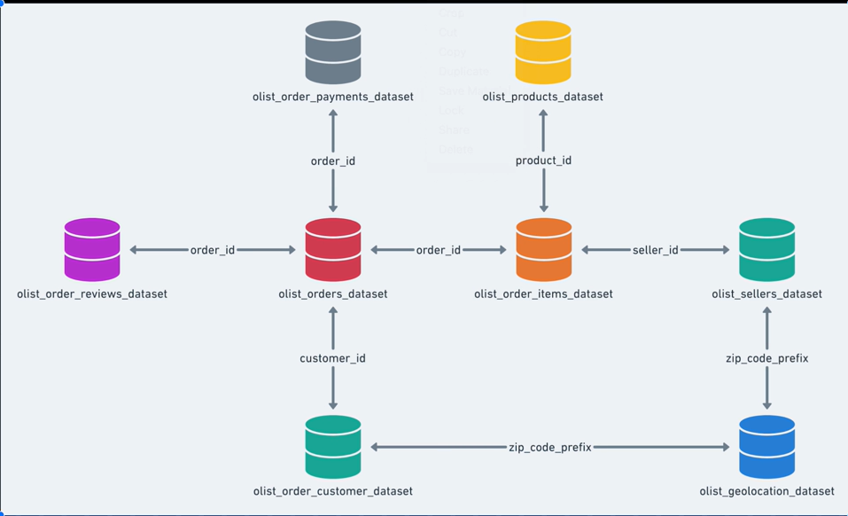

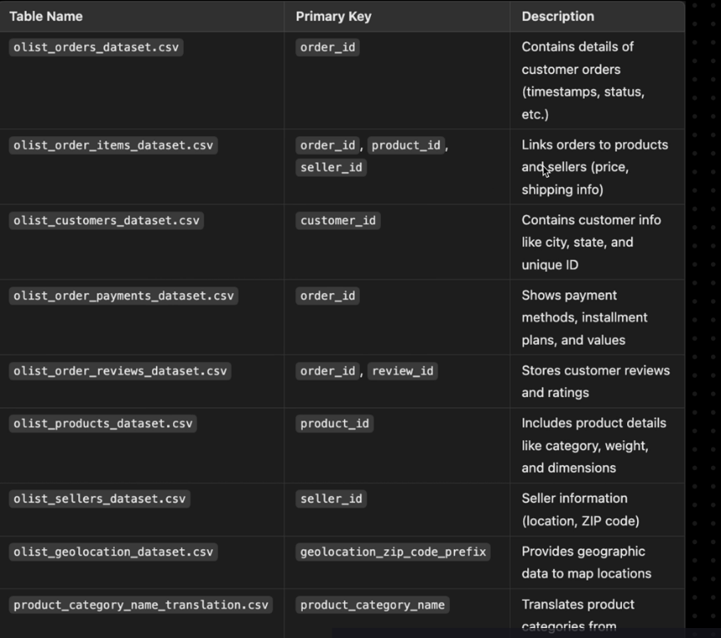

# Module 1 Data ingestion and exploration: -
- We will be focusing on productonize industry approach: -
  - Storing data into HDFS/object storage.
  - Using spark dataframe for scalable operation.
  - Exploration will focus on practical business use case.
  - We have to make sure to document everything.
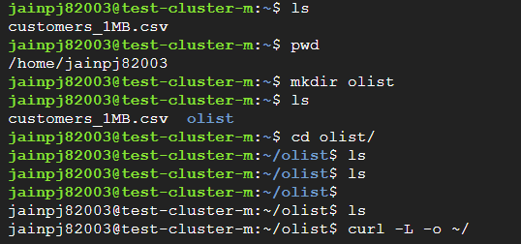

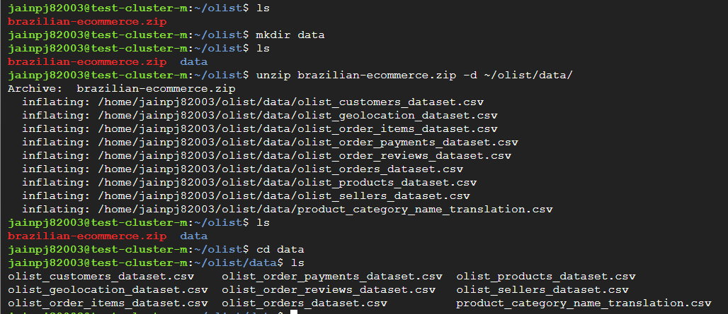

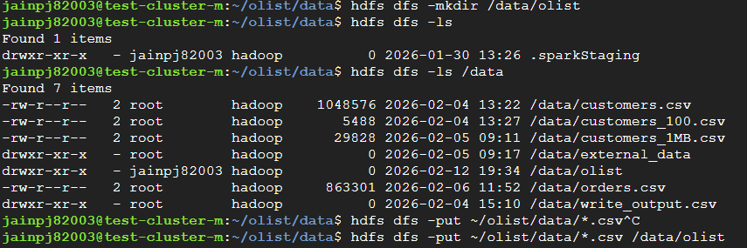

# Data exploration: -
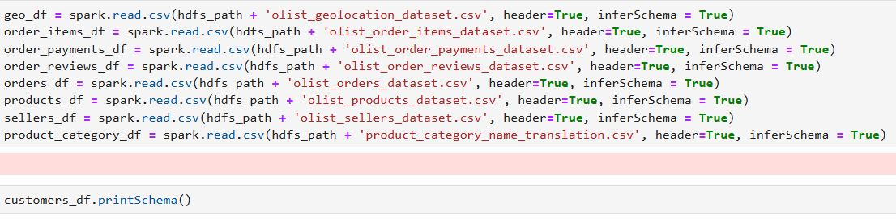
- Reading the data in dataframes and printing schema: -
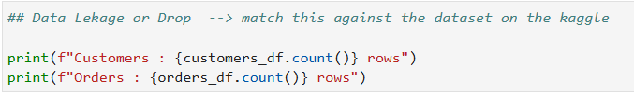
- Check for any data leakages: -

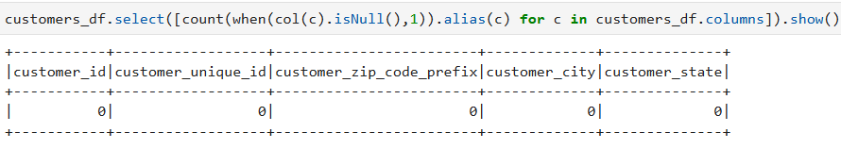
- Check for null values: -

- Check for duplicate values: -
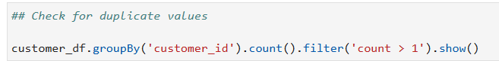

- Customer distribution by state: -

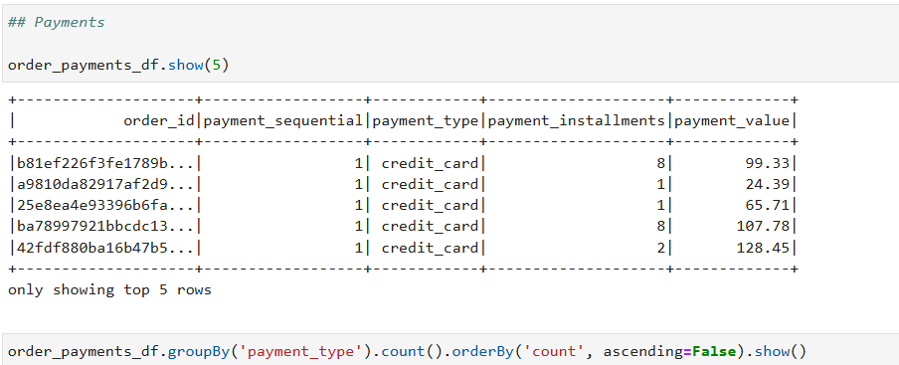
- Payments distribution: -

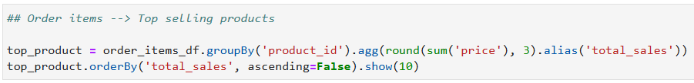
- Top selling products: -
- Average delivery time: -
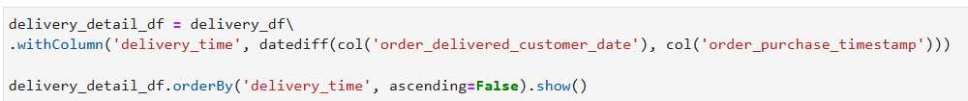

# Module 2 Data cleaning and Transformation: -
- This module will focus on real world data engineering practices for cleaning and transforming data at scale using pyspark.
- Steps in data cleaning and transformation: -
  - Identify issues (missing values, duplicates and invalid data)
  - Handle missing data (drop or fill null values, impute the missing values).
  - Standardize formats (converting data time, normalize categorical fields).
  - Data type correction (correct data type is there for each column).
  - De-duplication (remove duplicate records)
  - Data transformation (feature engineering)
  - Store clean data (data in HDFS in parquet)
- Identify missing values: -
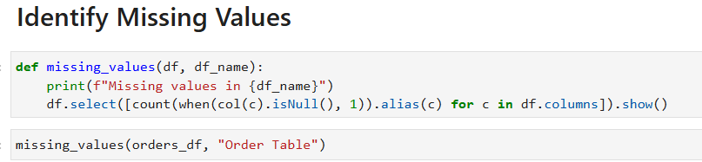

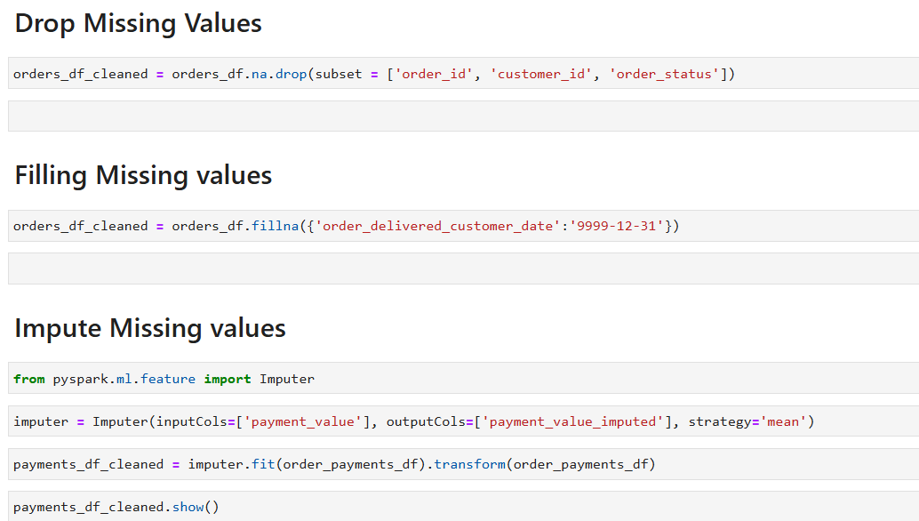
- Handle Missing values: -

- Standardizing the format: -
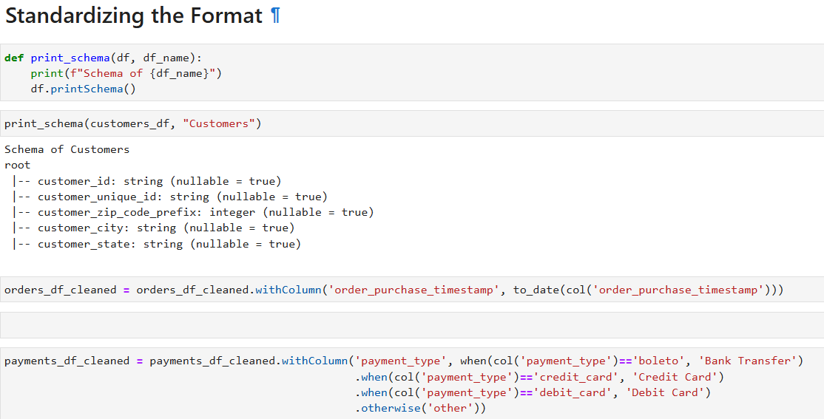

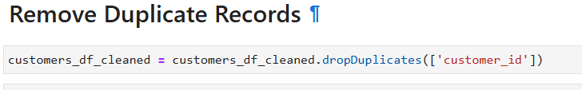
- Remove duplicate records: -

- Join datasets: -
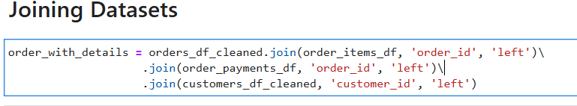

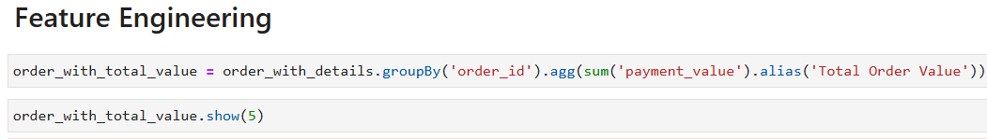
- Calculations/ Feature engineering: -

- Advance Transformations: -
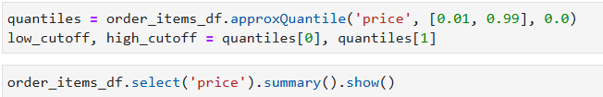

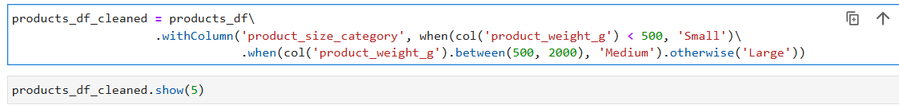
- Total Revenue per seller calculation: -
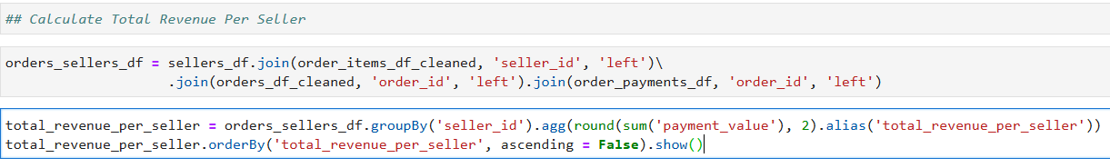

- Saving the cleaned dataframes in HDFS: -
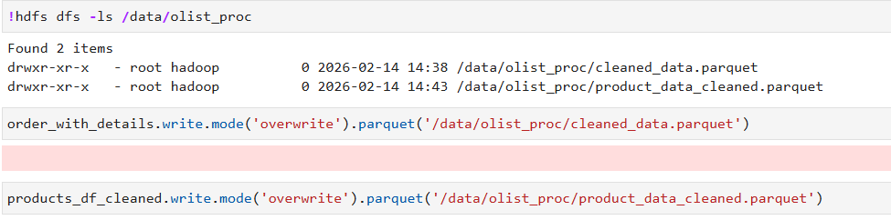

- Saving the cleaned data in Hive tables: -
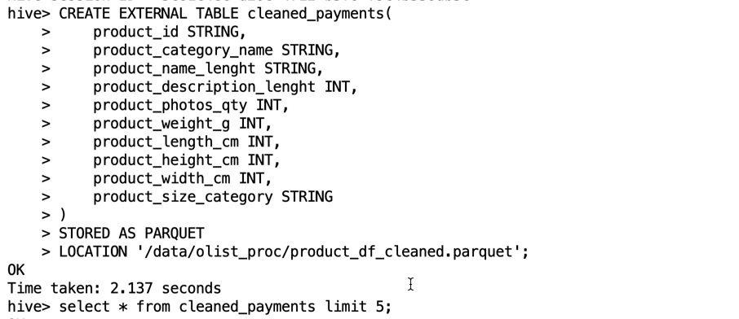

# Module 3 Data integration and aggregation: -
- Join datasets efficiently.
- Optimizing joins.
- Complex aggregations.
- Caching and optimizing queries for performance in real world use cases.
- broadcast() and shuffle(): -
  - It means sending a small dataset to all worker nodes.
  - So, spark avoids expensive data shuffling.
  - Normally if we use .join(), spark does shuffle join: -
    - In shuffle join, spark redistributes data across all nodes.
    - Move large chunk of data across the network.
    - Very slow and expensive.
  - Using broadcast(): -
    - We are telling spark to send the dataframe to every worker node.
    - Large dataset stays where it is.
    - Small dataset is copied to all nodes.
    - Joins happen locally inside each node.
    - No shuffle needed and it is much faster.
  - When to use broadcast(): -
    - One dataset is small
    - Other dataset is large
    - We want performance improvement
  - Broadcast joins improve performance by sending small dataset to all worker nodes, avoiding expensive shuffle operation during joining.
- Data Integration Joining all datasets: -
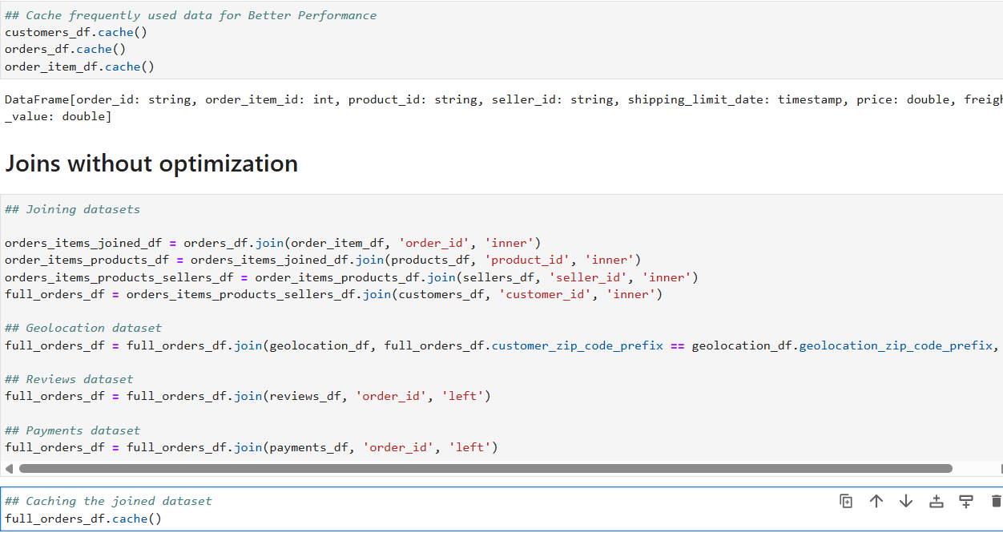

- Optimized joins aggregation and window: -
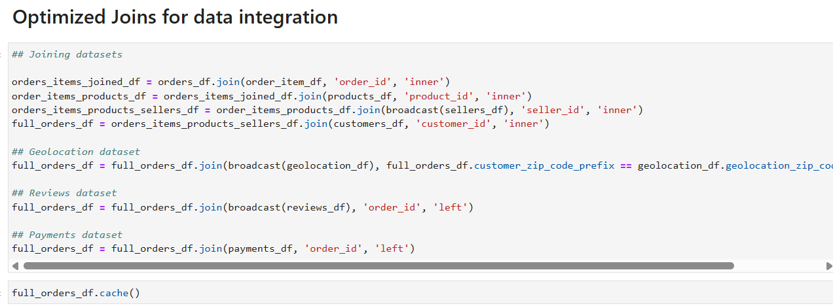

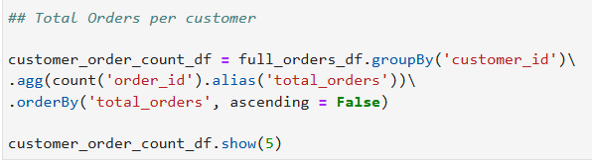

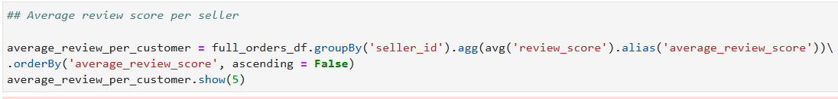

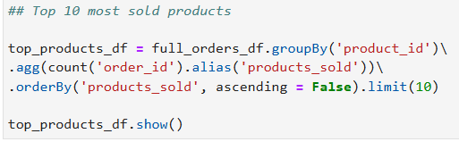

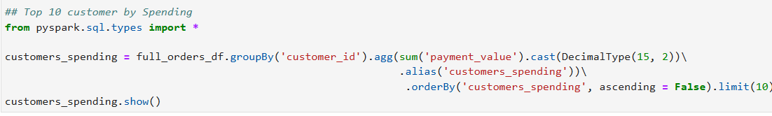
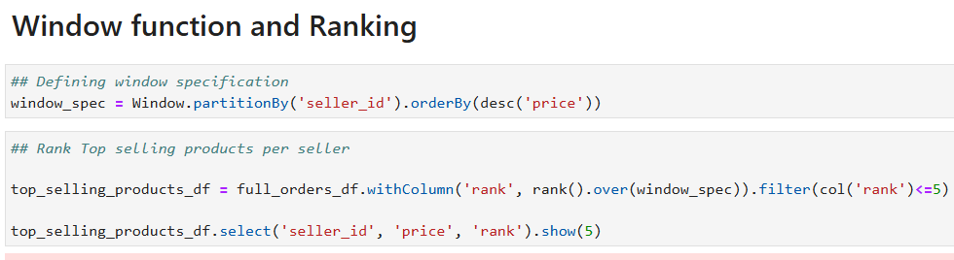

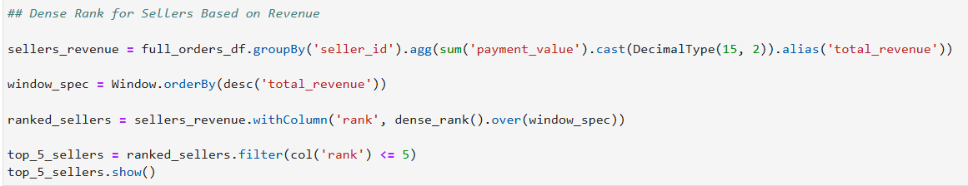

- Advance data aggregation: -
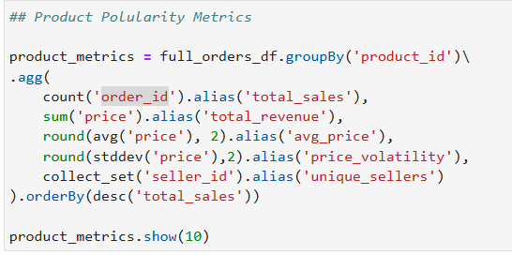
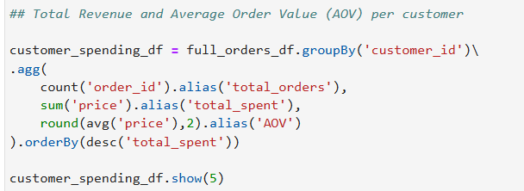
  - groupBy() doesn’t maintain ordering in spark. first() and last() return arbitrary values unless used with a properly ordered window function.
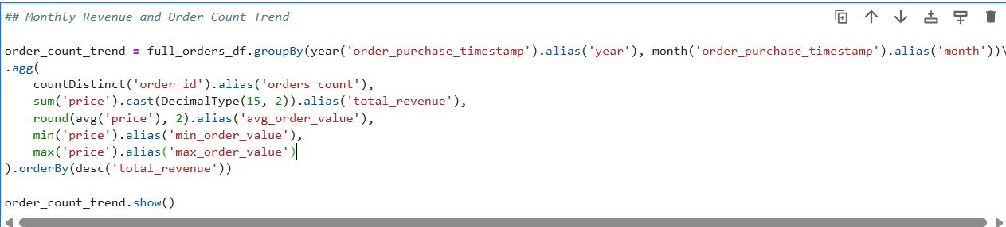

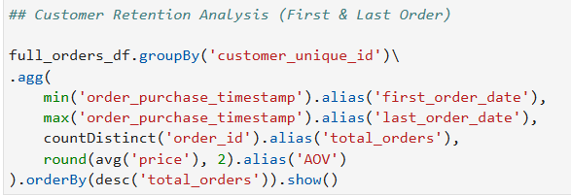

- Advance enrichment: -
  - lit(): -
    - it is used to create constant column value in spark expressions because spark transformations operate on column objects, not raw python values.
  - freight_value = shipping cost it is the amount charged to transport the product from the seller to the customer.
  - expr() allows writing SQL expressions inside PySpark and convert them into column objects. It converts SQL string into spark column object. For complex operations, using expr() becomes shorter.

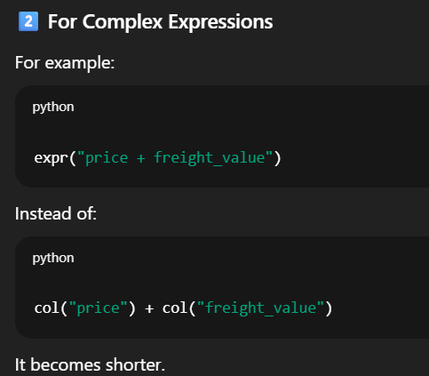

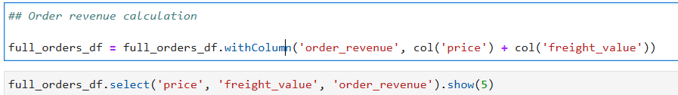
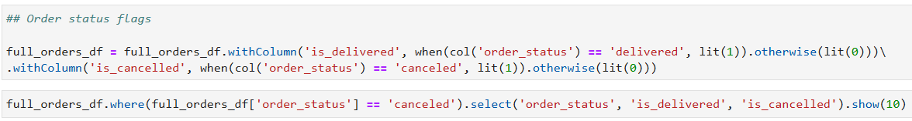

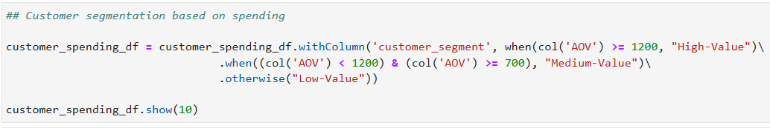
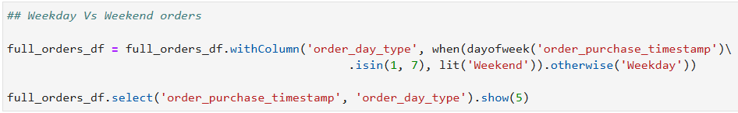
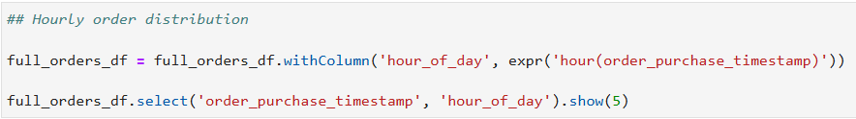

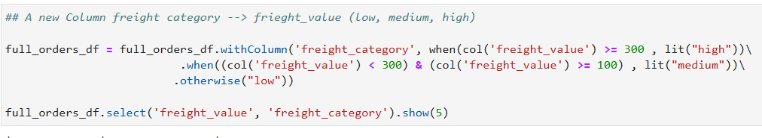

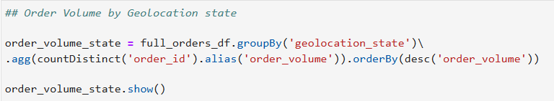

# Module 4 Spark configuration Optimization: -
- key consideration for dataproc cluster: -
  - Cluster resources: -
    - Master n2-standard-4 (4vCPUs, 16GB RAM, 32 GB disk).
    - Worker(2x) n2-standard-4 (4vCPUs, 16GB RAM, 64 GB Disk each).
    - Total 8 worker vCPUs, ~32 GB RAM (excluding master node).
  - Dataproc features disabled: -
    - No autoscaling, metastore, advance execution layer, advance optimizations.
    - Storage pd-balanced (no SSDs, so I/O optimization is crucial).
    - Networking: internal IP enabled.
  - Optimization strategy: -
    - Tune shuffle partitions, broadcast join threshold, and storage persistence.
    - Adjust parallelism based on 2 workers x 4 cores.
    - Avoid excessive caching due to disk-based-storage.
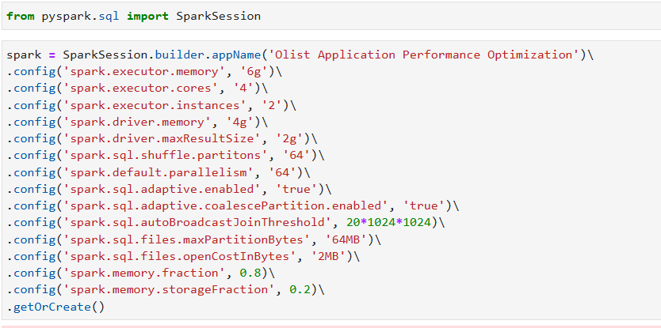

  - spark.executor.memory memory given to each executor (worker that run task). 6GB to each executor (12GB).
  - spark.executor.cores number of CPU cores per executor. Here in our case 4 task can run in parallel inside one executor. More cores = more parallelism. Too many cores per executor = less efficient scheduling.
  - spark.executor.instances number of executors. In our case (8 cores with 12GB memory) for 2 executors.
  - spark.driver.memory memory for driver program. Driver coordinates everything, collect results, run SparkSession.
  - spark.driver.maxResultSize maximum size of data, driver can receive. In our case, it our result is greater than 2GB then spark throws error.
  - spark.sql.shuffle.partitions number of partitions created during shuffle (join, groupBy). Default = 200, we set to 64. If data is small then 200 partitions is waste. 64 makes shuffle fast and efficient.
  - spark.default.parallelism default number of partitions for RDD operations. It controls how many parallel tasks spark creates. Usually set similar to shuffle partitions.
  - spark.sql.adaptive.enabled enables adaptive query execution (AQE). Spark automatically adjusts shuffle partitions, optimize joins, changes plan at runtime.
  - spark.sql.adaptive.coalescePartitions.enabled spark reduces small partitions automatically. E.g. we created 64 partitions but after filtering only 10 needed, spark merges them automatically.
  - spark.sql.autoBroadcastJoinThreshold max size for automatic broadcast join. Default is 10. In our case, we set it to 20 so if table < 20MB then spark automatically broadcast it, no shuffle and faster joins.
  - spark.sql.files.maxPartitionBytes control file reading partition size. If file is large, spark splits into chunks of 64MB. Smaller partition more parallelism but more overhead.
  - spark.sql.files.openCostInBytes cost model for opening files.
  - spark.memory.fraction in our case 0.8, it means 80% of executor memory is used for execution (shuffle, join) and storage. Default is 0.6.
  - spark.memory.storageFraction out of that 80%, 20% is reserved for caching data.
- Join Optimization Strategies: -
  - Broadcast Join: -
    - Sends the small table to each worker node.
    - Big table stays where it is.
    - Joins happen locally on each machine.
    - No shuffle of big data.
    - We use it because shuffle is expensive, data moves across network, slow and uses more memory.
    - We use it when one dataset is small and other is large.
  - Sort-Merge Join: -
    - Shuffles data.
    - Sorts both dataset by join key.
    - Merge them like merge step in merge sort.
    - Best for large dataset joins and when broadcast is not possible and join key is proportionally distributed. No extreme skew.
  - Bucket Join: -
    - It divides data into fixed buckets based on key.
    - If both datasets have same bucket count and key, spark can skip shuffle.
    - We use bucket joins when running repeated joins, very large datasets, data stored in hive.
    - Saves shuffle cost in repeated queries.
    - Used when same join used frequently and for big datasets.
  - Skew join: -
    - Data skew mean one key appears multiple times.
    - One executor becomes overloaded.
    - Job becomes slow.
    - Spark detect heavy keys, splits large partitions, distributes load better.
    - It prevents one executor doing all the work and long-running task.
    - It is used when some keys are very frequent, when one task runs much longer that others and in large joins.
- Data Serving layer: -
  - Save and retrieve processed data efficiently inside DataProc.
  - Serve data in structured way for analysis. Use parquet, hive and CSV.
